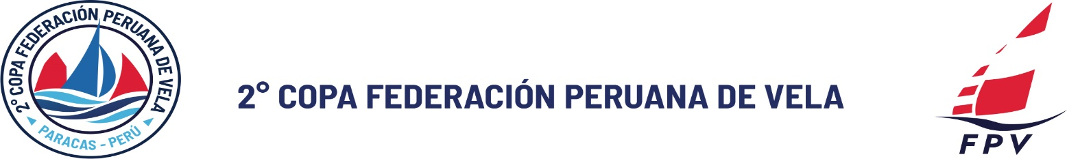

PARENT / GUARDIAN CONSENT FOR MINORS
This form shall be signed by the parent or legal guardian of any competitor under 18 years of age.

DISCLAIMER OF LIABILITY
Competitors are entirely responsible for their own safety, whether afloat or ashore, and nothing reduces this responsibility. It is for the competitors to decide whether their boat is in a seaworthy condition for the conditions that may arise. By launching, competitors confirm that their boat is fit to sail and to compete in the conditions that may be encountered.
No actions taken by the Organising Authority shall reduce the responsibility of the boat owners or competitors. The Organising Authority, the Race Committee and the International Jury shall not be held liable for any loss, damage, death or personal injury, however caused, that may occur as a result of participation in the even

Name of Competitor: ____________________________________________________
Name of Parent/Guardian: _______________________________________________
Address: ______________________________________________________________
Contact Telephone: _____________________________________________________
Person Responsible for the Competitor during the Event: _____________________
Telephone of Responsible Person: _________________________________________
Date and Signature of Parent/Guardian: ___________________________________
Date and Signature of Responsible Person: _________________________________

